9.1 Scatter Plots
Standards  8.SP.1 | Learning Objectives (I can…)  - Construct and interpret scatter plots  - Describe patterns in scatter plots

Key Idea
Scatter Plot
A __________________ is a graph that shows the relationship between two data sets. The two sets of data are graphed as ___________________ in a coordinate plane.

Example 1: Interpreting a Scatter Plot
The scatter plot at the left shows the amounts of fat (in grams) and the numbers of calories in 12 restaurant sandwiches.

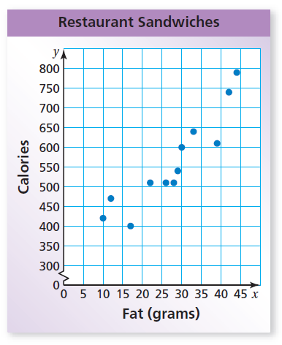

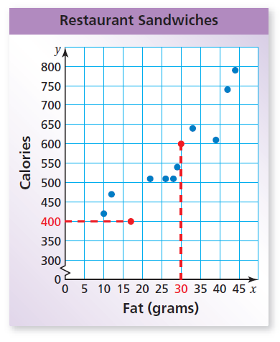
- How many calories are in the sandwich that contains 17 grams of fat?

- How many grams of fat are in the sandwich that contains 600 calories?

- What tends to happen to the number of calories as the number of grams of fat increases?

On Your Own:
WHAT IF? A sandwich has 650 calories. Based on the scatter plot in Example 1, how many grams of fat would you expect the sandwich to have? Explain your reasoning.

A scatter plot can show that a _______________ exists between two data sets.
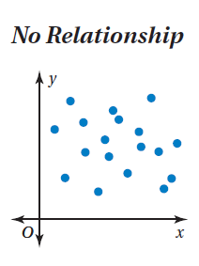
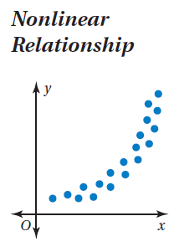
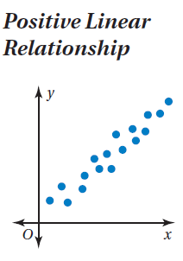
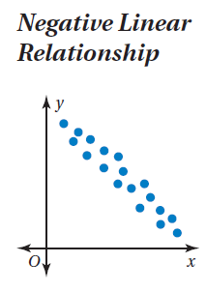

The points show
no ____________.
The points lie in the
shape of a ____________.
The points lie close to a line. As x increases,
y ____________.
The points lie close to
a line. As x increases,
y _____________.

Example 2: Identifying Relationships
Describe the relationship between the data. Identify any outliers, gaps, or clusters.

- Television size and price
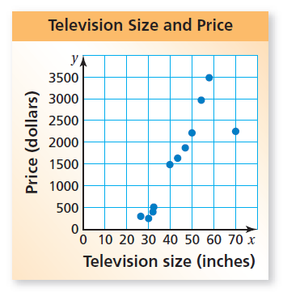

- Age and number of pets owned
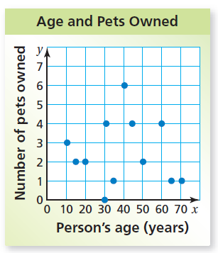

On Your Own:
Make a scatter plot of the data and describe the relationship between the data. Identify any outliers, gaps, or clusters.
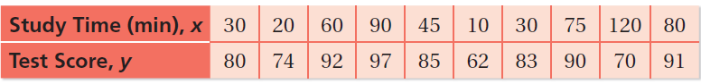

9.2 Lines of Fit
Standards  8.SP.1  8.SP.2  8.SP.3 | Learning Objectives (I can…)  - Find lines of fit  - Use lines of fit to solve problems

A __________________________ is a line drawn on a scatter plot close to most of the data points. It can be used to estimate data on a graph.

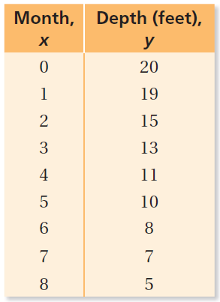
Example 1: Finding a Line of Fit
The table shows the depth of a river x months after a monsoon season ends.

- Make a scatter plot of the data and draw a line of fit.

- Write an equation of the line of fit.

- Interpret the slope and the y-intercept of the line of fit.

- Predict the depth in month 9.

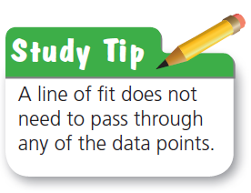

On Your Own:
The table shows the numbers of people who have attended a festival over an 8-year period.

- Make a scatter plot of the data and draw a line of fit.

- Write an equation of the line of fit.

- Interpret the slope and the y-intercept of the line of fit.

- Predict the number of people who will attend the festival in year 10.

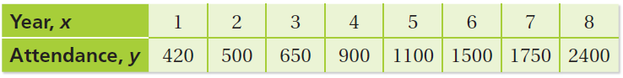

Graphing calculators use a method called _______________________ to find a precise line of fit called a _____________________________.

A calculator often gives a value _____ called the _____________________________. This value tells whether the correlation is positive or negative, and how closely the equation models the data.

Values of r range from ________________. When r is close to 1 or − 1, there is a ______________ correlation between the variables. As r gets closer to 0, the correlation becomes _________________.
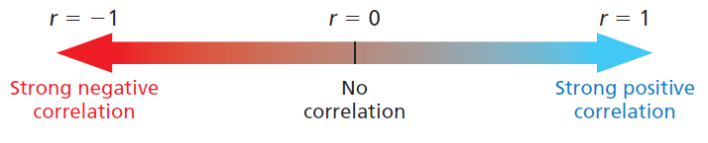

Example 2: Finding a Line of Fit Using Technology

The table shows the worldwide movie ticket sales y (in billions of dollars) from 2000 to 2011, where x = 0 represents the year 2000. Use a graphing calculator to find an equation of the line of best fit. Identify and interpret the correlation coefficient.

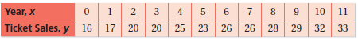

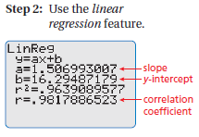
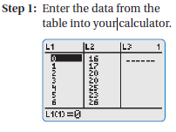

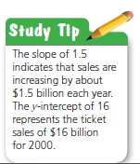

9.3 Two-Way Tables
Standards  8.SP.4 | Learning Objectives (I can…)  - Read two-way tables  - Make and interpret two-way tables

A _________________ displays two categories of data collected from the same source.

You randomly survey students in your school about their grades on the last test and whether they studied for the test. The ___________________ shows your results. Each entry in the table is called a _______________________.

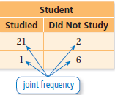

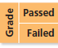

Example 1: Reading a Two-Way Table
How many of the students in the survey above studied for the test and passed?

The entry in the __________________ column and _________________ row is ________.

How many of the students in the survey above studied for the test and failed?

The sums of the rows and columns in a two-way table are called ____________________________.

Example 2: Finding Marginal Frequencies
Find and interpret the marginal frequencies for the survey below.
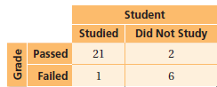
Create a new column and a new row for the sums. Then add the entries.

On Your Own:
1. You randomly survey students in a cafeteria about their plans for a football game and a school dance. The two-way table shows your results.

- How many students will attend the dance but not the football game?

- Find and interpret the marginal frequencies for the survey.

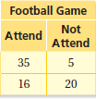

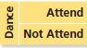

Example 3: Making a Two-Way Table
You randomly survey students between the ages of 12 and 17 about whether they ride the bus to school. The results are shown in the tally sheets. Make a two-way table that includes the marginal frequencies.

The two categories for the table are the ages and whether or not they ride the bus. Use the tally sheets to calculate each joint frequency. Then add to find each marginal frequency.
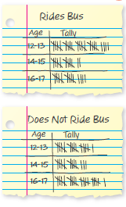

Example 4: Finding a Relationship in a Two-Way Table
Use the two-way table in Example 3.
- For each age group, what percent of the students in the survey ride the bus to school? Do not ride the bus to school? Organize the results in a two-way table. Explain what one of the entries represents.

- Does the table in part (a) show a relationship between age and whether students ride the bus to school? Explain.

On Your Own:
2. You randomly survey students in a school about whether they buy a school lunch or pack a lunch. Your results are shown.

- Make a two-way table that includes the marginal frequencies.

b. For each grade level, what percent of the students in the survey pack a lunch? Buy a school lunch?
Organize the results in a two-way table. Explain what one of the entries represents.

c. Does the table in part (b) show a relationship between grade level and lunch choice? Explain.

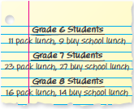

9.4 Choosing a Data Display
Standards  8.SP.1 | Learning Objectives (I can…)  - Choose appropriate data displays  - Identify and analyze misleading data displays

Key Idea
Data Display What does it do? What does it look like?

Pictograph

Bar Graph

Circle Graph

Line Graph

Histogram

Stem-and-Leaf Plot

Box-and-Whisker Plot

Dot Plot

Scatter Plot

Example 1: Choosing an Appropriate Data Display
Choose an appropriate data display for the situation. Explain your reasoning.

- the number of students in a marching band each year

- a comparison of people’s shoe sizes and their heights

On Your Own:
Choose an appropriate data display for the situation. Explain your reasoning.

- The population of the United States divided into age groups

- The percent of students in your school who play basketball, football, soccer, or lacrosse

Extra Example 1!
You conduct a survey at your school about insects that students fear the most. Choose an appropriate data display. Explain your reasoning.

Example 2: Identifying an Appropriate Data Display
You record the number of hits for your school’s new website for 5 months. Tell whether the data display is appropriate for representing how the number of hits changed during the 5 months. Explain your reasoning.

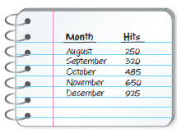
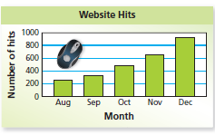
a)

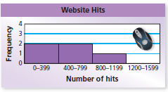
b)

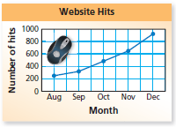
c)

On Your Own:
Tell whether the data display is appropriate for representing the data in Example 2. Explain your reasoning.

3. dot plot 4. circle graph 5. stem-and-leaf plot

Example 3: Identifying an Misleading Data Display
Which line graph is misleading? Explain.

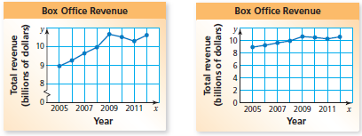

Example 4: Analyzing an Misleading Data Display
A volunteer concludes that the numbers of cans of food and boxes of food donated were about the same. Is this conclusion accurate? Explain.

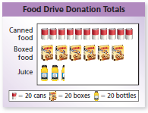

On Your Own:
Explain why the data display is misleading.

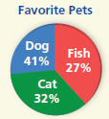
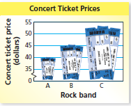
6. 8.

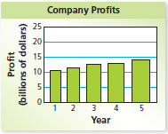
7.

