7.1 Finding Square Roots
Standards  8.EE.2 | Learning Objectives (I can…)  - Find square roots of perfect squares  - Evaluate expressions involving square roots  - Use square roots to solve equations

A __________________ of a number is a number that, when multiplied by itself, equals the given number. Every positive number has a positive and a negative square root. A _____________ is a number with integers as its square roots.
Example 1: Finding Square Roots of a Perfect Square
Find the two square roots of 49.

The symbol ____ is called a radical sign. It is used to represent a square root. The number under the radical sign is called the _______________.
Positive Square Root, | Negative Square Root, | Both Square Roots,

Example 2: Finding Square Roots
Find the square root(s).
- $\sqrt{25}$

- $-\sqrt{\frac{9}{16}}$

- $±\sqrt{2}.25$

On Your Own:
Find the two square roots of the number.
- 36 2. 100 3. 121

Find the square root(s).
4. $-\sqrt{1}$ 5. $±\sqrt{\frac{4}{25}}$ 6. $\sqrt{12.25}$

Squaring a positive number and finding a square root are ____________ operations. You can use this relationship to evaluate expressions and solve equations involving squares.

Example 3: Evaluating Expressions Involving Square Roots
Evaluate each expression.
- $5\sqrt{36}+7$

- $\frac{1}{4}+\sqrt{\frac{18}{2}}$

- ${(\sqrt{8}1)}^{2}-5$

Example 4: Real-Life Application
The area of a crop circle is 45,216 square feet. What is the radius of the crop circle? Use 3.14 for 𝛑.

On Your Own:
Evaluate the expression.
7. $12-3\sqrt{25}$ 8. $\sqrt{\frac{28}{7}}+2.4$ 9. $15-{(\sqrt{4})}^{2}$

10. The area of a circle is 2826 square feet. Write and solve an equation to find the radius of the circle. Use 3.14 for π.

7.2 Finding Cube Roots
Standards  8.EE.2 | Learning Objectives (I can…)  - Find cube roots of perfect cubes  - Evaluate expressions involving cube roots  - Use cube roots to solve equations

A ________________of a number is a number that, when multiplied by itself, and then multiplied by itself again, equals the given number. A _________________ is a number that can be written as the cube of an integer. The symbol _______________ is used to represent a cube root.

Example 1: Finding Cube Roots
Find each cube root.
- $\sqrt[3]{8}$

- $\sqrt[3]{-27}$

- $\sqrt[3]{\frac{1}{64}}$

Cubing a number and finding a cube root are _______________ operations. You can use this relationship to evaluate expressions and solve equations involving cubes.

Example 2: Evaluating Expressions Involving Cube Roots
Evaluate each expression.
- $2\sqrt[3]{-216}-3$

- ${(\sqrt[3]{125})}^{3}$

On Your Own:
Find the cube root.
- $\sqrt[3]{1}$ 2. $\sqrt[3]{-343}$ 3. $\sqrt[3]{\frac{-27}{1000}}$

Evaluate the expression.

- $18-4\sqrt[3]{8}$ 5. ${(\sqrt[3]{-64})}^{3}+43$ 6. $5\sqrt[3]{512}-19$

Example 3: Evaluating an Algebraic Expression
Evaluate $\frac{x}{4}+\sqrt[3]{\frac{x}{3}}$ when $x=192$.

On Your Own:
Evaluate the expression for the given value of the variable.

7. $\sqrt[3]{8y}+y ;y=64$ 8. $2b-\sqrt[3]{9b} ; b=-3$

Example 4: Real-Life Application
Find the surface area of the baseball display case.

The baseball display case is in the shape of a cube. Use the formula for the volume of a cube to find the edge length s.
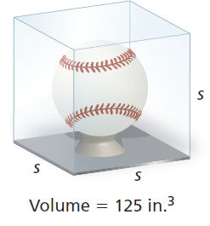

On Your Own:
9. The volume of a music box that is shaped like a cube is 512 cubic centimeters. Find the surface area of the music box.

7.3 Pythagorean Theorem
Standards  8.EE.2  8.G.6  8.G.7  8.G.9 | Learning Objectives (I can…)  - Provide a geometric proof of the Pythagorean Theorem  - Use the Pythagorean Theorem to find missing side lengths of right triangles  - Solve real-life problems

Key Idea
Sides of a Right Triangle
The sides of a right triangle have special names.
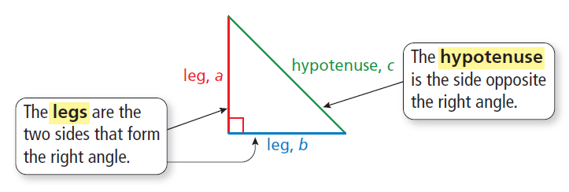

The Pythagorean Theorem
Words: In any right triangle, the sum of the squares of the lengths of the legs is equal to the square of the length of the ____________________.

Algebra:

Example 1: Finding the Length of a Hypotenuse
Find the length of the hypotenuse of the triangle.

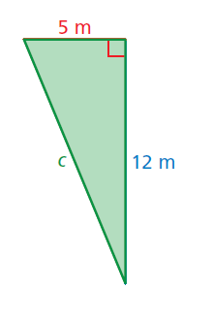

On Your Own:
Find the length of the hypotenuse of the triangle.
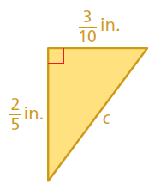
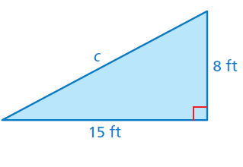
- 2.

Example 2: Find the Length of the Leg
Find the missing length of the triangle.
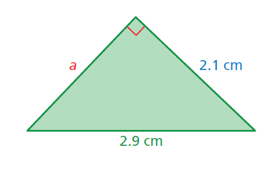

On Your Own:
Find the missing length of the triangle.
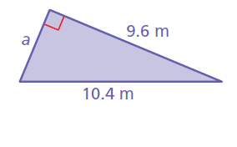
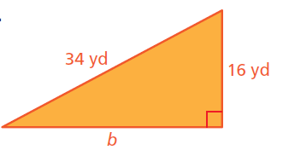
3. 4.

Example 3: Real-Life Application
You are playing capture the flag. You are 50 yards north and 20 yards east of your team’s base. The other team’s base is 80 yards north and 60 yards east of your base. How far are you from the other team’s base?

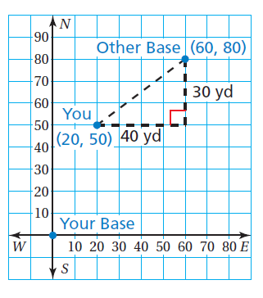

7.4 Approximating Square Roots
Standards  8.NS.1  8.NS.2  8.EE.2 | Learning Objectives (I can…)  - Define irrational numbers  - Approximating square roots  - Approximating values of expressions involving irrational numbers

A rational number is a number that can be written as the ratio of two integers. An ___________________ cannot be written as the ratio of two integers.

- The square root of any whole number that is not a perfect square is _______________. The cube root of any integer that is not a perfect cube is irrational.
- The decimal form of an irrational number neither terminates nor _______________.

Key Idea
Real Numbers

Rational numbers and irrational numbers together form the set of ___________________.
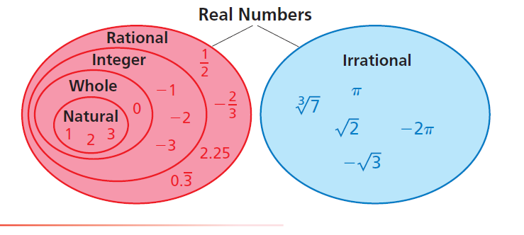

Example 1: Classifying Real Numbers
Classify each real number.
Number | Subset(s) | Reasoning
On Your Own:
Classify the real number.
- $0.121221222…$ 2. $-\sqrt{196}$ 3.$\sqrt[3]{2}$

Example 2: Approximating a Square Root
Estimate $\sqrt{71}$ to the nearest (a) integer and (b) tenth.
- Make a table of numbers whose squares are close to 71.
Number
Square of Number

- Make a table of numbers between 8 and 9 whose squares are close to 71.

Number
Square of Number

On Your Own:
Estimate the square root to the nearest (a) integer and (b) tenth.

4. $\sqrt{8}$ 5. $-\sqrt{13}$ 6. $\sqrt{110}$

Example 3: Comparing Real Numbers
Which is greater, $\sqrt{5}$ or $\frac{2}{3}$ ?
Estimate $\sqrt{5}$ to the nearest integer. Then graph the numbers on a number line.

Example 4: Approximating the Value of an Expression
The radius of a circle with area A is approximately $\sqrt{\frac{A}{3 }}$ . The area of a circular mouse pad is 51 square inches. Estimate its radius to the nearest integer.

Example 5: Real-Life Application
The distance (in nautical miles) you can see with a periscope is $1.17\sqrt{h }$, where h is the height of the periscope above the water. Can you see twice as far with a periscope that is 6 feet above the water than with a periscope that is 3 feet above the water? Explain.

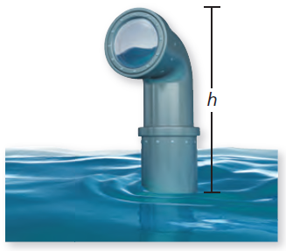

On Your Own:
Which number is greater? Explain.

7. $4\frac{1}{5} , \sqrt{23}$ 8. $\sqrt{10} , -\sqrt{5}$ 9. $-\sqrt{2} , -2$

Extension 7.4 Repeating Decimals
Standards  8.NS.1 | Learning Objectives (I can…)  - Write a repeating decimal as a fraction

Key Idea
Writing a Repeating Decimal as a Fraction
Let a variable x equal the repeating decimal d.

Step 1:

Step 2:

Step 3:

Step 4:

Example 1: Writing a Repeating Decimal as a Fraction (1 Digit Repeats)
Write $0.\overline{4}$ as a fraction in simplest form.

Example 2: Writing a Repeating Decimal as a Fraction (1 Digit Repeats)
Write $-0.2\overline{3}$ as a fraction in simplest form.

On Your Own:
Write the decimal as a fraction or a mixed number.

- $0.\overline{1}$ 2. $-0.\overline{5}$ 3. $-1.\overline{2}$ 4. $5.\overline{8}$

Example 3: Writing a Repeating Decimal as a Fraction (2 Digit Repeats)
Write $1.2\overline{5}$ as a mixed number.

7.5 Using the Pythagorean Theorem
Standards  8.EE.2  8.G.6  8.G.7  8.G.8 | Learning Objectives (I can…)  - Use the converse of the Pythagorean Theorem to identify right triangles  - Use the Pythagorean Theorem to find distances in a coordinate plane  - Solve real-life problems

Key Idea
Converse of the Pythagorean Theorem

If the equation ____________________is true for the side lengths of a triangle, then the triangle is a right triangle.
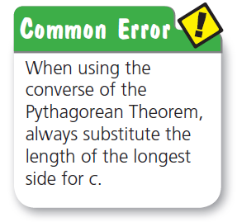
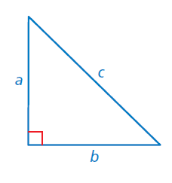

Example 1: Identifying a Right Triangle
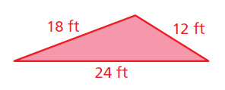
Tell whether each triangle is a right triangle.
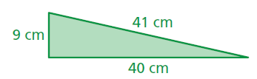
- 2.

On Your Own:
Tell whether each triangle is a right triangle with the given side lengths.

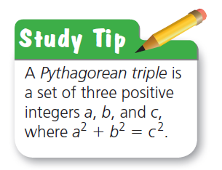
- 28 in., 21 in., 20 in. 2. 1.25 mm, 1 mm, 0.75 mm

Key Idea
The distance d between any two points $(x_{1},y_{1})$ and $(x_{2},y_{2})$ is given by the formula
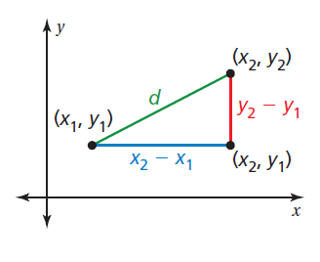
______________________.

Example 2: Finding the Distance Between Two Points
Find the distance between (1, 5) and (−4, −2).

On Your Own:
Find the distance between the two points.
3. (0, 0), (4, 5) 4. (7, − 3), (9, 6) 5. (− 2, − 3), (− 5, 1)

Example 3: Real-Life Application
You design a football play in which a player runs down the field, makes a 90°turn, and runs to the corner of the end zone. Your friend runs the play as shown. Did your friend make a 90°turn? Each unit of the grid represents 10 feet.

