**6.1 Relations of Functions**

|  |  |
| --- | --- |
| **Standards**  8.F.1 | **Learning Objectives (I can…)**   * Define relations and functions * Determine whether relations are functions * Describe patterns in mapping diagrams |

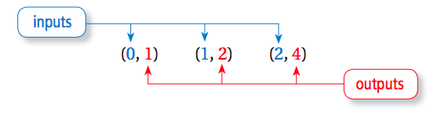Ordered pairs can be used to show ______________ and __________________.

**Key Idea**

**Relations and Mapping Diagrams**

A ________________ pairs inputs with outputs. A relation can be represented by ordered pairs or a ________________________.

***Ordered Pairs Mapping Diagram***

**Example 1:** Listing Ordered Pairs of a Relation

**List the ordered pairs shown in the mapping diagram.**

1. 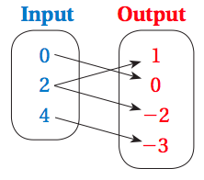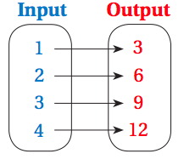**b.**

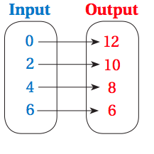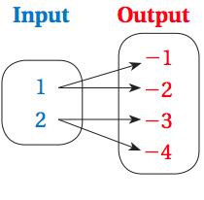**On Your Own:** List the ordered pairs in the mapping diagram.

1. **2.**

A relation that pairs each input with *exactly one* output is a ____________________.

**Example 2:** Determining whether Relations are Functions

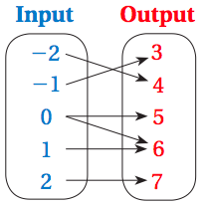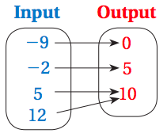 **Determine whether each relation is a function.**

1. **b.**

**Example 3:** Describing a Mapping Diagram

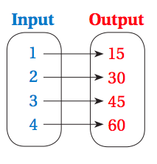 **Consider the mapping diagram at the right.**

1. **Determine whether the relation is a function.**
2. **Describe the pattern of inputs and outputs in the mapping diagram**

**On Your Own:** Determine whether the relation is a function.

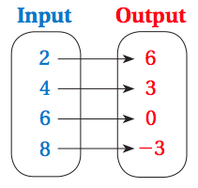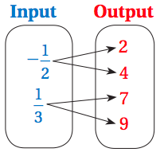 **3. 4.**

**5.** Describe the pattern of inputs and outs in problem 4.

**6.2 Representations of Functions**

|  |  |
| --- | --- |
| **Standards**  8.F.1 | **Learning Objectives (I can…)**   * Write function rules * Use input-output tables * Use graphs to represent functions |

**Key Idea**

**Functions as Equations**

A _______________________ is an equation that describes the relationship between inputs (independent variable) and outputs (dependent variable).

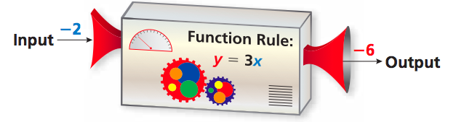

**Example 1:** Writing Function Rules

1. **Write a function rule for “The output is five less than the input.”**

Words:

Equation:

1. **Write a function rule for “The output is the square of the input.”**

Words:

Equation:

**Example 2:** Evaluating a Function

**What is the value of**  **when** .

**On Your Own:**

1. Write a function rule for “The output is one-fourth of the input.”

**Find the value a**  **when** .

**2.**  **3.**  **4.** 

**Key Idea**

**Functions as Tables and Graphs**

A function can be represented by an _________________________________ and by a _______________. The table and graph below represent the function .

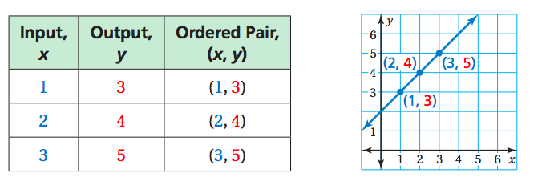

By drawing a line through the points, you graph *all* of the solutions of the function .

**Example 3:** Graphing a Function

**Graph the function**  **using the inputs -1, 0, 1, and 2.**

Make an input-output table.

|  |  |  |  |
| --- | --- | --- | --- |
| Input, x |  | Output, y | Ordered Pair, (x,y) |
|  |  |  |  |
|  |  |  |  |
|  |  |  |  |
|  |  |  |  |

Plot the ordered pairs and draw a line through the points

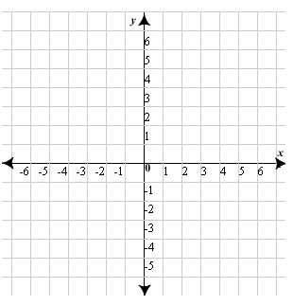

**On Your Own:** Graph the Function

**5.**  **6.** 

**Example 4:** Real-Life Application

**The number of pounds *p* of carbon dioxide produced by a car is 20 times the number of gallons *g* of gasoline used by the car. Write and graph a function that describes the relationship between *p* and *g*.**

Write a function rule using the variables *g* and *p*.

Words:

Equation:

Make and input-output table that represents the function .

|  |  |  |  |
| --- | --- | --- | --- |
| Input, *g* | 20*g* | Output, *p* | Ordered Pair, (*g*,*p*) |
|  |  |  |  |
|  |  |  |  |
|  |  |  |  |

Plot the ordered pairs and draw a line through the points. (Because you cannot have a negative number of gallons, use only positive values of *g*.)



**Summary**

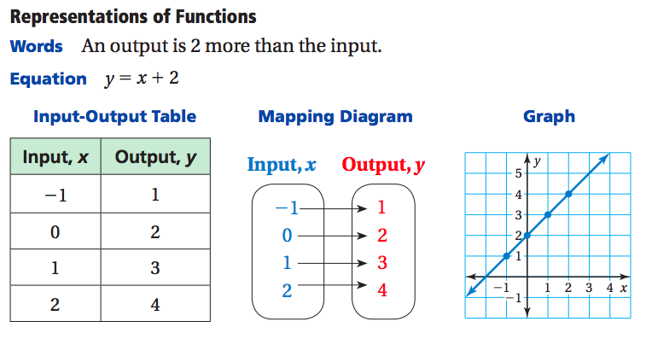

**6.3 Linear Functions**

|  |  |
| --- | --- |
| **Standards**  8.F.2  8.F.3  8.F.4 | **Learning Objectives (I can…)**   * Understand that the equation y=mx+b defines a linear equation * Write linear functions using graphs or tables * Compare linear functions |

A ______________________ is a function whose graph is a nonvertical line. A linear function can be written in the form _________________, where *m* is the slope and *b* is the y-intercept.

**Example 1:** Writing a Linear Function Using a Graph

**Use the graph to write a linear function that relates *y* to *x*.**

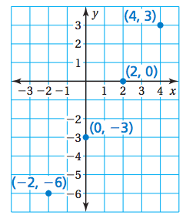

**Example 2:** Writing a Linear Function Using a Table

**Use the table to write a linear function that relates *y* to *x*.**

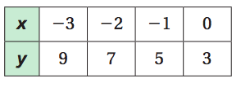



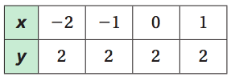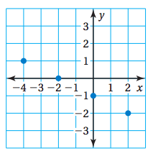**On Your Own:** Use the graph or table to write a linear function that relates *y* to *x*.

1. **2.**

**Example 3:** Real-Life Application

**You are controlling an unmanned aerial vehicle for surveillance. The table shows the height *y* (in thousands of feet) of the UAV *x* minutes after you start its descent from cruising altitude.**

1. 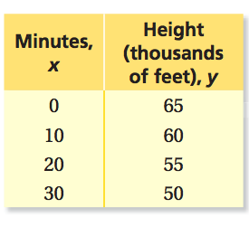Write a linear function that relates *y* to *x*. Interpret the slope and the y-intercept.
2. Graph the linear function.



1. Find the height of the UAV when you stop the descent after 1 hour.

**Example 4:** Comparing Linear Functions

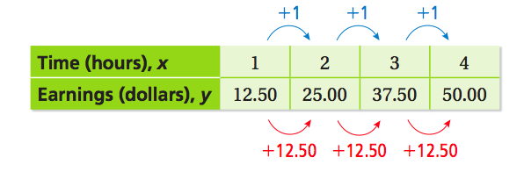**The earnings *y* (in dollars) of a nighttime employee working *x* hours are represented by the linear function** . **The table shows the earnings of a daytime employee.**

1. Which employee has a higher hourly wage?
2. Write a linear function that relates the daytime employee’s earning to the number.

**6.4 Comparing Linear and Nonlinear Functions**

|  |  |
| --- | --- |
| **Standards**  8.F.3 | **Learning Objectives (I can…)**   * Identify linear and nonlinear functions from tables or graphs * Compare linear and nonlinear functions |

The graph of a linear function shows a constant rate of change. A ______________________ does not have a constant rate of change. So, its graph is not a ___________________.

**Example 1:** Identifying Functions from Tables

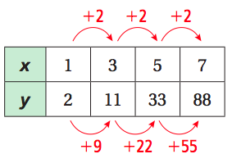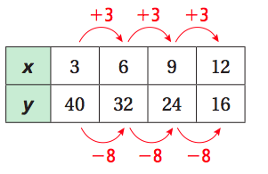 **Does the table represent a *linear* or *nonlinear* function? Explain.**

1. **b.**

**Example 2:** Identifying Functions form Graphs

**Does the graph represent a *linear* or *nonlinear* function? Explain.**

1. 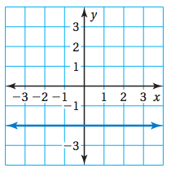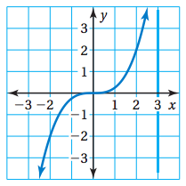**b.**

**On Your Own:** Does the table or graph represent a *linear* or *nonlinear* function? Explain.

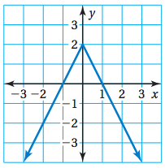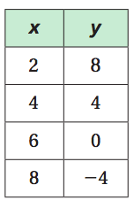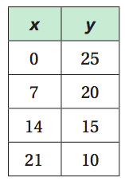 **1. 2. 3.**

**Example 3:** Identifying a Nonlinear Function

**Which equation represents a *nonlinear* function?**

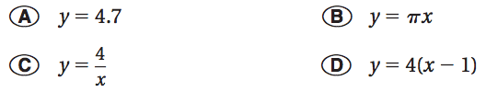

**Example 4:** Real-Life Application

**Account A earns simple interest. Account B earns compound interest. The table shows the balance for 5 years. Graph the data and compare graphs.**

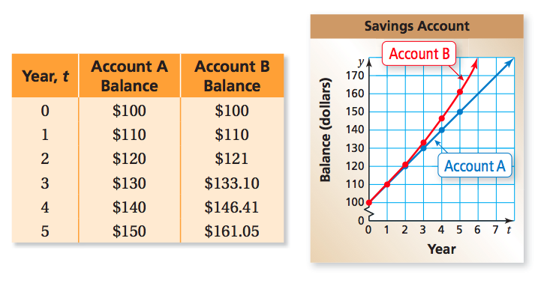

**6.5 Analyzing and Sketching Graphs**

|  |  |
| --- | --- |
| **Standards**  8.F.5 | **Learning Objectives (I can…)**   * Analyze the relationship between two quantities using graphs * Sketch graphs to represent the relationship between two quantities |

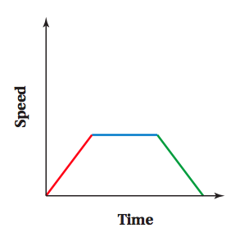Graphs can show the relationship between quantities without using specific numbers on the axes.

**Example 1:** Analyzing Graphs

**The graphs show the temperatures throughout the day in two cities.**

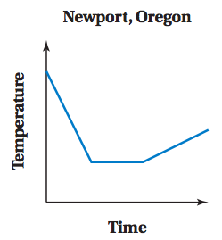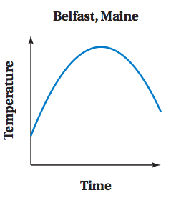

1. Describe the change in temperature in each city.

Belfast:

Newport:

1. Make three comparisons from the graphs

1.

2.

3.

**On Your Own:**

1. 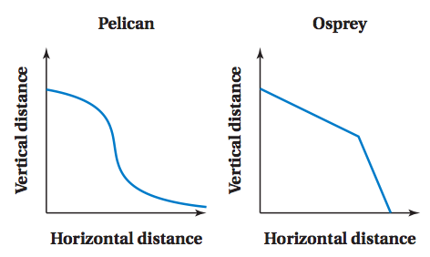The graphs show the paths of two birds diving to catch a fish.

Describe the path of each bird.

Pelican:

Osprey:

**Example 2:** Sketching Graphs

**Sketch a graph that represents each situation**

1. A stopped subway train gains speed at a constant rate until it reaches its maximum speed. It travels at this speed for a while, and then slows down at a constant rate until coming to a stop at the next station.
2. As television size increases, the price increases at an increasing rate.

**On Your Own:** Sketch a graph that represents the situation.

1. A fully charged battery loses its charge at a constant rate until it has no charge left. You plug it in and recharge fully. Then it loses its charge at a constant rate until it has no charge left.
2. As the available quantity of a product increase, the price decreases at a decreasing rate.