5.1 Solving Systems of Linear Equations by Graphing
Standards  8.EE.8a  8.EE.8b  8.EE.8c | Learning Objectives (I can…)  - Write and solve systems of linear equations by graphing.  - Solve real-life problems

A __________________________________________________ is a set of __________ or more linear equations in the same variables. An example is shown below.
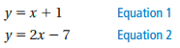

A _______________________ of a system of linear equations in two variables is an ____________________________ that is a solution of each equation in the system. The solution of a system of linear equations is the point of _________________________ of the graphs of the equations.

Key Idea
Solving a System of Linear Equations by Graphing

Step 1:

Step 2:

Step 3:

Example 1: Solving a System of Linear Equations by Graphing
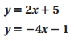
Solve the system by graphing.

Step 1:

Step 2:

Step 3:

On Your Own: Solve the system of linear equations by graphing.
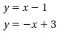
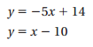
- 2.

Example 2: Real-Life Application
A kicker on a football team scores 1 point for making an extra point and 3 points for making a field goal. The kicker makes a total of 8 extra points and field goals in a game and scores 12 points. Write and solve a system of linear equations to find the number x of extra points and the number y of field goals.

On Your Own: Solve the system of linear equations by graphing.
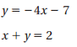
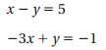
- 4.

5.2 Solving Systems of Linear Equations by Substitution
Standards  8.EE.8b  8.EE.8c | Learning Objectives (I can…)  - Write and solve systems of linear equations by substitution.  - Solve real-life problems.

Key Idea
Solving a System of Linear Equations by Substitution

Step 1:

Step 2:

Step 3:

Example 1: Solving a System of Linear Equations by Substitution
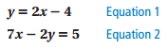
Solve the system by substitution.

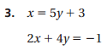
On Your Own: Solve the system of linear equations by substitution. Check your solution.
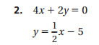
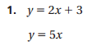

Example 2: Real-Life Application
You buy a total of 50 turkey burgers and veggie burgers for $90. You pay $2 per turkey burger and $1.50 per veggie burger. Write and solve a system of linear equations to find the number x of turkey burgers and the number y of veggie burgers you buy.

On Your Own:
- A juice stand sells lemonade for $2 per cup and orange juice for $3 per cup. The juice stand sells a total of 100 cups of juice for $240. Write and solve a system of linear equations to find the number of cups of lemonade and the number of cups of orange juice sold.

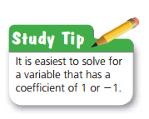

5.3 Solving Systems of Linear Equations by Elimination
Standards  8.EE.8b  8.EE.8c | Learning Objectives (I can…)  - Write and solve systems of linear equations by elimination.  - Solve real-life problems.
Key Idea
Solving a System of Linear Equations by Elimination
Step 1:

Step 2:

Step 3:

Step 4:

Example 1: Solving a System of Linear Equations by Elimination
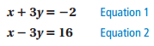
Solve the system by elimination.

On Your Own: Solve the system of linear equations by elimination. Check your solution.
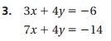
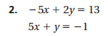
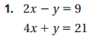

Example 2: Solving a System of Linear Equations by Elimination
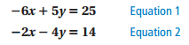
Solve the system by elimination.

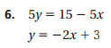
On Your Own: Solve the system of linear equations by elimination. Check your solution.
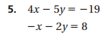
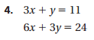

Example 3: Real-Life Application
You buy 8 hostas and 15 daylilies for $193. Your friend buys 3 hostas and 12 daylilies for $117. Write and solve a system of linear equations to find the cost of each daylily.

Summary:

5.4 Solving Special Systems of Linear Equations
Standards  8.EE.8a  8.EE.8b  8.EE.8c | Learning Objectives (I can…)  - Solve systems of linear equations having no solution or infinitely many solutions.

Key Idea
Solutions of Systems of Linear Equations
A system of linear equations can have _________________________, _______________________, or ________________________________________________.
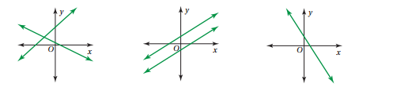

Example 1: Solving a System: No Solution
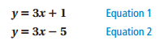
Solve the system.

On Your Own: Solve the system of linear equations. Check your solution.

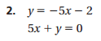
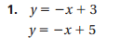
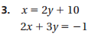

Example 2: Solving a System: Infinitely Many Solutions
The perimeter of the rectangle is 36 units. The perimeter of the triangle is 108 units. Write and solve a system of linear equations to find the values of x and y.
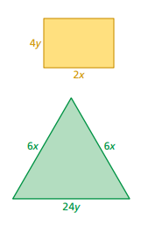

On Your Own: Solve the system of linear equations. Check your solution.

