4.1 Graphing Linear Equations
Standards  8.EE.5 | Learning Objectives (I can…)  - Understand that lines represent solutions of linear equations  - Graph linear equations

Key Idea
Linear Equations

A _______________________________ is an equation whose graph is a _________________. The points on the line are ____________________________ of the equation.

You can use a graph to show the solutions of a linear equation. The
graph below is for the equation y = x + 1.
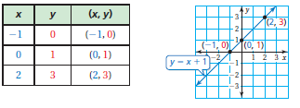

Example 1: Graphing a Linear Equation
Graph $y=-2x+1$
Step 1: Make a _________________ of values.

Step 2: Plot the __________________________.

Step3: Draw a _____________ through the points.

Key Idea
Graphing Horizontal and Vertical Lines
The graph of _________ is a horizontal The graph of ___________ is a vertical
line passing through (0, b). line passing through (a, 0).

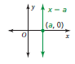
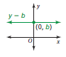

Example 2: Graphing a Horizontal Line and a Vertical Line
- Graph $y=-3$ b. Graph $x=2$

On Your Own: Graph the linear equation. Use a graphing calculator to check your
graph, if possible.
- $y=3x$ 2. $y=-\frac{1}{2}x+2$

- $x=-4$ 4. $y=-1.5$

Example 3: Real-Life Application
The wind speed y (in miles per hour) of a tropical storm is y = 2x + 66, where x is the number of hours after the storm enters the Gulf of Mexico.

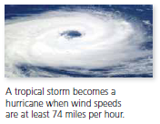
- Graph the Equation
- When does the storm become a hurricane?

On Your Own:
- WHAT IF? In Example 3, the wind speed of the storm is y = 1.5x + 62. When does the storm become a hurricane?

4.2 Slope of a Line
Standards  8.EE.6 | Learning Objectives (I can…)  - Find slopes of lines using two points  - Find slopes of lines from tables

Key Idea
Slope

Slope of a line in the Coordinate Plane
The slope of a line is a __________________ of the change in _____ (the rise) to the change in ______ (the run) between any _______________ points, ( , ) and ( , ) on the line.
Slope =
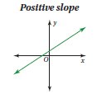
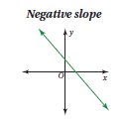

Example 1: Finding the Slope of a Line
Describe the slope of the line. Then find the slope.

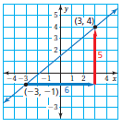
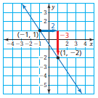
- b)

On Your Own:
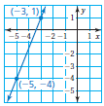
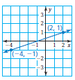
Find the slope of the line.
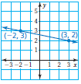
- 2. 3.

Example 2: Finding the Slope of a Horizontal Line
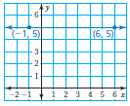
Find the slope of the line.

Example 3: Finding the Slope of a Vertical Line
Find the slope of the line.
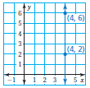

On Your Own:
Find the slope of the line through the given points.
- $(1,-2)(7,-2)$ 5. $(-3,-3)(-3,-5)$ 6. $(0,8)(0,0)$

- How do you know that the slope of every horizontal line is 0? How
do you know that the slope of every vertical line is undefined?

Example 4: Finding Slope from a Table
The points in the table lie on a line. How can you find the slope of the line from the table? What is the slope?
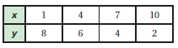

On Your Own:
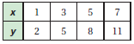
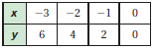
- 9.

Summary:
Slope
Positive Slope Negative Slope

Slope of Zero Undefined Slope

4.2 Extension: Slopes of Parallel and Perpendicular Lines
Standards  8.EE.6 | Learning Objectives (I can…)  - Identify parallel and perpendicular lines

Key Idea
Parallel Lines and Slopes
Lines in the same plane that do not __________________ are parallel lines. Nonvertical parallel lines have the same ________________.
Example 1: Identifying Parallel Lines
Which two lines are parallel? How do you know?
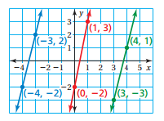

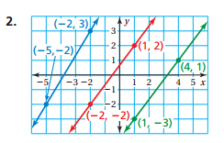
On Your Own: Which two lines are parallel? How do you know?
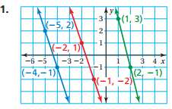

Key Idea
Perpendicular Lines and Slope
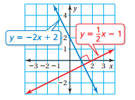
Lines in the same plane that intersect at _____________________________ are perpendicular lines. Two nonvertical lines are perpendicular when the ____________________ of their slopes is − 1.

Example 2: Identifying Perpendicular Lines
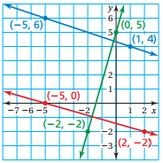
Which two lines are perpendicular? How do you know?

On Your Own: Which two lines are perpendicular? How do you know?
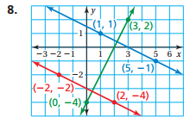
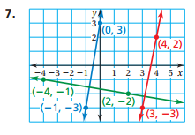

4.4 Graphing Linear Equations in Slope-Intercept Form
Standards  A.CED.2  A.REI.10  F.IF.4 | Learning Objectives (I can…)  - Find slopes and y-intercepts of graphs of linear equations  - Graph linear equations written in slope-intercept form

Key Idea
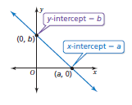
Intercepts
The ______________________ of a line is the ______________________ of the point where
the line _______________________ the x-axis. It occurs when y = 0.

The _______________________ of a line is the ________________________ of the point where
the line ________________________ the y-axis. It occurs when x = 0.

Slope-Intercept Form

A linear equation written in the form __________________________ is in slope-intercept form. The _____________________ of the line is m and the ______________________________ of the line is b.

Example 1: Identifying Slopes and y-Intercepts
Find the slope and y-intercept of the graph of each linear equation.
- $y=-4x-2$

- $y-5=\frac{3}{2}x$

On Your Own:
Find the slope and y-intercept of the graph of the linear equation.
- $y=3x-7$ 2. $y-1=-\frac{2}{3}x$

Example 2: Graphing a Linear Equation in Slope-Intercept Form
Graph y = −3x + 3. Identify the x-intercept.

Example 3: Real-Life Application
The cost y (in dollars) of taking a taxi x miles is y = 2.5x + 2.
(a) Graph the equation. (b) Interpret the y-intercept and slope.

On Your Own:
Graph the linear equation. Identify the x-intercept. Use a graphing calculator to check your answer.

- $y=x-4$ 4. $y=\frac{1}{2}x+1$

- In Example 3, the cost y (in dollars) of taking a different taxi x miles is y = 2x + 1.5. Interpret the y-intercept and slope.

4.5 Graphing Linear Equations in Standard Form
Standards  A.CED.2  A.REI.10  F.IF.4 | Learning Objectives (I can…)  - Graph linear equations written in standard form.

Key Idea
Standard Form of a Linear Equation
The __________________ of a linear equation is

where a and b are not both zero.

Example 1: Graphing a Linear Equation in Standard Form
Graph −2x + 3y = −6.

On Your Own:
Graph the linear equation. Use a graphing calculator to check your graph.

- $x+y=-2$ 2. $-\frac{1}{2}x+2y=6$

Example 2: Graphing a Linear Equation in Standard Form
Graph x + 3y = −3 using intercepts.

Example 3: Real-Life Application
You have $6 to spend on apples and bananas. (a) Graph the equation 1.5x + 0.6y = 6, where x is the number of pounds of apples and y is the number of pounds of bananas. (b) Interpret the intercepts.

On Your Own:
- $2x-y=8$

- WHAT IF? In Example 3, you buy y pounds of oranges instead of bananas. Oranges cost $1.20 per pound. Graph the equation 1.5x + 1.2y = 6. Interpret the intercepts.

4.6 Writing Equations in Slope-Intercept Form
Standards  8.F.3  A.CED.2  A.CED.3 | Learning Objectives (I can…)  - Write equations of lines in slope-intercept form.

Example 1: Writing Equations in Slope-Intercept Form

Write an equation of the line in slope-intercept form.

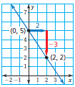

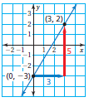

On Your Own:
Write an equation of the line in slope-intercept form.

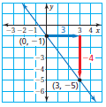
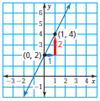
- 2.

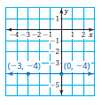
Example 2: Writing an Equation

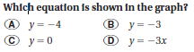

Find the slope and y-intercept.

Example 3: Real-Life Application

The graph shows the distance remaining to complete a tunnel. (a) Write an equation that represents the distance y (in feet) remaining after x months. (b) How much time does it take to complete the tunnel?
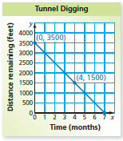
- Find the slope and y-intercept.

- The tunnel is complete when the distance remaining is 0 feet. So,
find the value of x when y = 0.

On Your Own:
- Write an equation of the line that passes through (0, 5) and (4, 5).

4.7 Writing Equations in Point-Slope Form
Standards  A.CED.2  A.REI.10  F.IF.4  F.IF.6 | Learning Objectives (I can…)  - Write equations of lines using a slope and a point.  - Write equations of lines using two points.

Key Idea
Point-Slope Form

A linear equation written in the form __________________________ is in point-slope form. The line passes through the point _________________ and the slope of the line is _______.

Example 1: Writing an Equation Using a Slope and a Point

Write in point-slope form an equation of the line that passes through the point (−6, 1) with slope $\frac{2}{3}$.

On Your Own:
Write in point-slope form an equation of the line that passes through the given point and has the given slope.

1. (1, 2); m = − 4 2. (7, 0); m = 1 3. (− 8, − 5); m = $-\frac{3}{4}$

Example 2: Writing an Equation Using Two Points

Write in slope-intercept form an equation of the line that passes through the points (2, 4) and (5, −2).

Example 3: Real-Life Application

You finish parasailing and are being pulled back to the boat. After 2 seconds, you are 25 feet above the boat. (a) Write and graph an equation that represents your height y (in feet) above the boat after x seconds. (b) At what height were you parasailing?

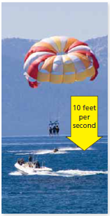

On Your Own:
Write in slope-intercept form an equation of the line that passes through the given points.

- (− 2, 1), (3, − 4) 5. (− 5, − 5), (− 3, 3)

- (− 8, 6), (− 2, 9)

- WHAT IF? In Example 3, you are 35 feet above the boat after 2 seconds. Write and graph an equation that represents your height y (in feet) above the boat after x seconds.

