3.1 Parallel Lines and Transversals
Standards  8.G.5 | Learning Objectives (I can…)  - Identify the angles formed when parallel lines are cut by a transversal.  - Find the measures of angles formed when parallel lines are cut by a transversal.

Lines in the same plane that do not _____________________ are called _________________________ lines.
Lines that intersect at _______________________ are called ______________________________________ lines.
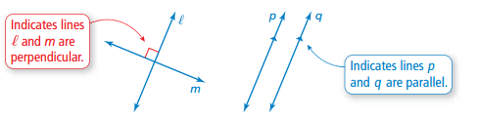

A line that intersects ___________________________________ lines is called a __________________________. When parallel lines are cut by a transversal, several pairs of _______________ angles are formed.

Key Idea
Corresponding Angles

When a transversal intersects parallel lines, ______________________ angles are congruent.

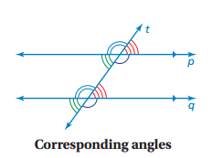

Example 1: Finding Angle Measures
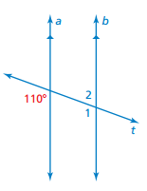

On Your Own: Use the figure to find the measure of the angle. Explain your reasoning.

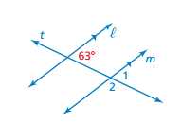

Example 2: Using Corresponding Angles
Use the figure to find the measures of the numbered angles.
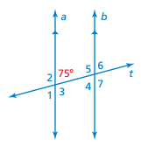
On Your Own:
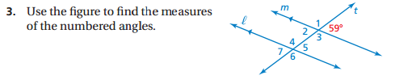

When two ____________________________________ are cut by a transversal, ____________ interior angles are formed on the ___________________ of the parallel lines and ______________ exterior angles are formed on the ___________________ of the parallel lines.
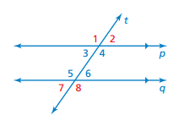

Example 3: Using Corresponding Angles
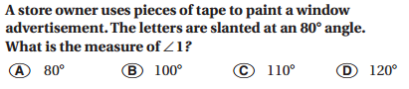

On Your Own:

Key Idea
Alternate Interior Angles and Alternate Exterior Angles
When a transversal intersects parallel lines, _____________________________________________ are congruent and ___________________________________________________ are congruent.
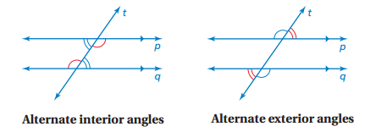

Example 4: Identifying Alternate Interior and Alternate Exterior Angles
The photo shows a portion of an airport. Describe the relationship between each pair of angles.
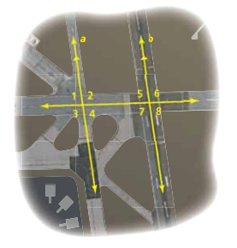

On Your Own:

3.2 Angles of Triangles
Standards  8.G.5 | Learning Objectives (I can…)  - Understand that the sum of the interior angle measures of a triangle is 180 degrees.  - Find the measure of the interior and exterior angles of a triangle.

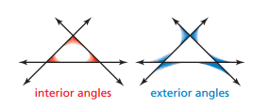
The angles inside a polygon are called __________________________________. When the sides of a polygon are extended, other angles are formed. The angles outside the polygon that are _______________________ to the interior angles are called ___________________________________________.

Key Idea
Interior Angle Measures of a Triangle
The sum of the interior angle measures of a triangle is __________________.
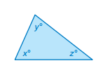
x + y + z = __________

Example 1: Using Interior Angle Measures
Find the value of x.

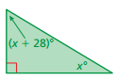
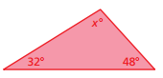
- b)

On Your Own: Find the value of x.
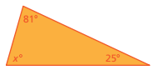
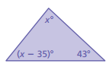
- 2.

Key Idea
Exterior Angle Measures of a Triangle
The ________________ of an exterior angle of a triangle is equal to the _____________ of the measures of the two nonadjacent _____________________ angles.
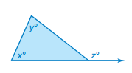

__________ = x + y

Example 2: Finding Exterior Angle Measures
Find the measure of the exterior angle.
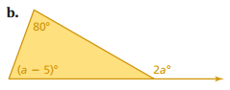
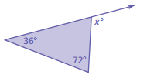

Example 3: Real-Life Application
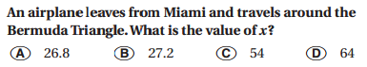
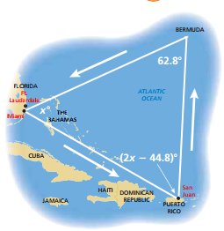

On Your Own: Find the measure of the exterior angle.

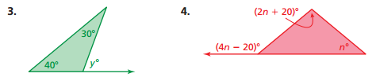

3.3 Angles of Polygons
Standards  8.G.5 | Learning Objectives (I can…)  - Find the sum of the interior angles measures of a polygon.  - Understand that the sum of the exterior angle measures of a polygon is 360 degrees.

A ______________________ is a closed plane figure made up of _____________________________ line segments that intersect only at their ______________________.
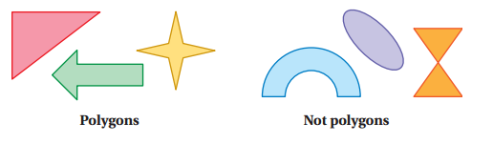
Key Idea
Interior Angle Measures of a Polygon

The sum S of the interior angle measures of a polygon with n sides is:

Example 1: Finding the Sum of the Interior Angle Measures
Find the sum of the interior angle measures of the school crossing sign.

On Your Own: Find the sum of the interior angle measures of the green polygon.
- 2.

Example 2: Finding an Interior Measure of a Polygon
Find the value of x.
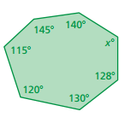

On Your Own: Find the value of x.
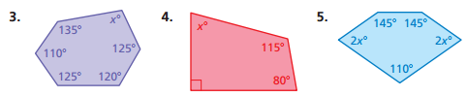

In a ___________________________ polygon, all the sides are_______________________, and all the interior angles are ___________________________.
Example 3: Real-Life Application
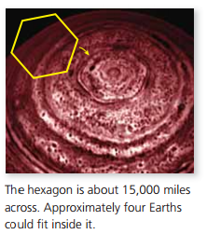
A cloud system discovered on Saturn is in the approximate shape of a regular hexagon. Find the measure of each interior angle of the hexagon.

On Your Own: Find the measure of each interior angle of the regular polygon.

Key Idea
Exterior Angle Measures of a Polygon
The sum of the measures of the ________________ angles of a convex polygon is _________.
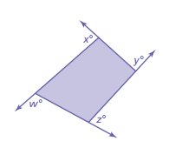

w + x + y + z = ______________

Example 4: Finding Exterior Angle Measures
Find the measures of the exterior angles of each polygon.
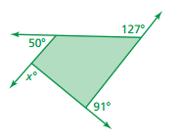
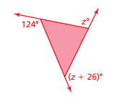
- b.

3.4 Using Similar Triangles
Standards  8.G.5 | Learning Objectives (I can…)  - Understand the concept of similar triangles.  - Identify similar triangles.
Key Idea
Angles of Similar Triangles
When __________ angles in one triangle are ____________ to two angles in another triangle, the ______________ angles are also congruent and the triangles are similar.

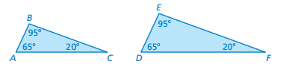

Triangle ABC is similar to Triangle DEF : _________________________________.
Example 1: Identifying Similar Triangles
Tell whether the triangles are similar. Explain.
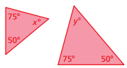

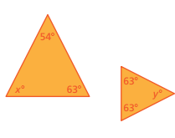

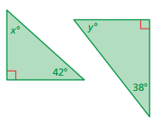

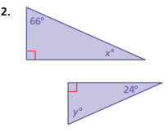
On Your Own: Tell whether the triangles are similar. Explain.
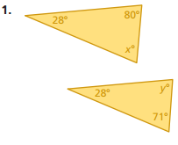

Indirect ________________________________ uses similar figures to find a ___________________ measure when it is difficult to find directly.
Example 2: Using Indirect Measurement
You plan to cross a river and want to know how far it is to the other side. You take measurements on your side of the river and make the drawing shown. (a) Explain why △ABC and △DEC are similar. (b) What is the distance x across the river?
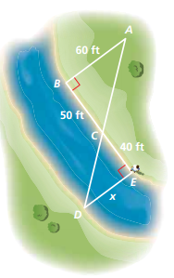

On Your Own:
