2.1 Congruent Figures
Standards  8.G.2 | Learning Objectives (I can…)  - Name corresponding angles and corresponding sides of congruent figures.  - Identify congruent figures.

Key Idea
Congruent Figures

Figures that have the ____________________ and the ____________________ are called congruent figures. The triangles below are congruent.

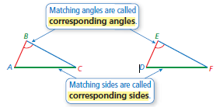

Example 1: Naming Corresponding Parts
The figures are congruent. Name the corresponding angles and the corresponding sides.

Corresponding Angles Corresponding Sides

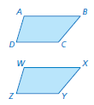

On Your Own: The figures are congruent. Name the corresponding angles and the corresponding sides.

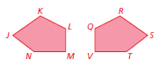

Key Idea
Identifying Congruent Figures
Two figures are congruent when corresponding __________________ and corresponding ____________________ are congruent.
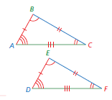
Triangle _________ is congruent to Triangle __________.

Example 2: Identifying Congruent Figures
Which square is congruent to Square A?
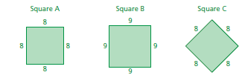

Example 3: Using Congruent Figures
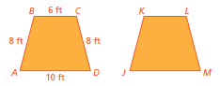
Trapezoids ABCD and JKLM are congruent.

- What is the length of side JM?

- What is the perimeter of JKLM?

On Your Own:
- Which square in Example 2 is congruent to Square D?

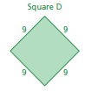

- In Example 3, which angle of JKLM corresponds to ∠C ? What is the length of side KJ ?

2.2 Translations
Standards  8.G.1  8.G.2  8.G.3 | Learning Objectives (I can…)  - Identify translations  - Translate figures in the coordinate plane

Key Idea
A ___________________________ changes a figure into another figure. The new figure
is called the __________________.
A _________________ is a transformation in which a figure ______________ but does not turn. Every point of the figure moves the same _______________ and in the same ________________.

Example 1: Identifying a Translation
Tell whether the blue figure is a translation of the red figure.

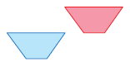
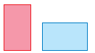
- b)

On Your Own:
Tell whether the blue figure is a translation of the red figure. Explain.
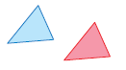
- 2. 3.

Key Idea
Translations in the Coordinate Plane
To _________________ a figure a units horizontally and b units vertically in a coordinate plane, __________ a to the x-coordinates and b to the y-coordinates of the vertices. Positive values of a and b represent translations _________ and _________. Negative values of a and b represent translations __________ and ___________.

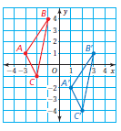

Algebra:

In a translation, the original figure and its image are congruent.
Example 2: Translating a Figure in the Coordinate Plane
Translate the red triangle 3 units right and 3 units down. What are the coordinates of the image?
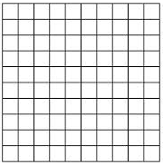

On Your Own:
- WHAT IF? The red triangle is translated 4 units left and 2 units up. What are the coordinates of the image?

Example 3: Translating a Figure Using Coordinates
The vertices of a square are A(1, −2), B(3, −2), C(3, −4), and D(1, −4). Draw the figure and its image after a translation 4 units left and 6 units up.

Vertices of ABCD | ( x , y ) | Vertices of A’B’C’D’

On Your Own:
- The vertices of a triangle are A(−2, −2), B(0, 2), and C(3, 0). Draw the figure and its image after a translation 1 unit left and 2 units up.

2.3 Reflections
Standards  8.G.1  8.G.2  8.G.3 | Learning Objectives (I can…)  - Identify reflections.  - Reflect figures in the x-axis or the y-axis of the coordinate plane.
Key Idea
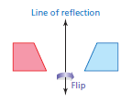
A _________________, or _____________, is a transformation in which a figure is reflected in a line called the __________________. A reflection creates a mirror image of the _____________ figure.

Example 1: Identifying a Reflection
Tell whether the blue figure is a reflection of the red figure.
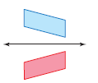
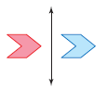
- b.

On Your Own:
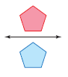
Tell whether the blue figure is a reflection of the red figure. Explain.
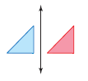
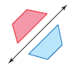
- 2. 3.

Key Idea
To reflect a figure in the x-axis, take the __________ of the y-coordinate.

To reflect a figure in the y-axis, take the __________ of the x-coordinate.

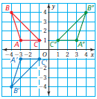
Algebra: To reflect a figure in the x-axis:

To reflect a figure in the y-axis:

In a reflection, the original figure and its image are _______________.

Example 2: Reflecting a Figure in the x-axis
The vertices of a triangle are A(−1, 1), B(−1, 3), and C(6, 3). Draw the figure and its reflection in the x-axis. What are the coordinates of the image?

Vertices of ABC | ( x , -y ) | Vertices of A’B’C’

Example 3: Reflecting a Figure in the y-axis
The vertices of a quadrilateral are P(−2, 5), Q(−1, −1), R(−4, 2), and S(−4, 4). Draw the figure and its reflection in the y-axis.

Vertices of PQRS | ( -x , y ) | Vertices of P’Q’R’S’

On Your Own:
4. The vertices of a rectangle are A(−4, −3), B(−4, −1), C(−1, −1), and D(−1, −3).
a. Draw the figure and its reflection in the x-axis.
b. Draw the figure and its reflection in the y-axis.
c. Are the images in parts (a) and (b) congruent? Explain.

2.4 Rotations
Standards  8.G.1  8.G.2  8.G.3 | Learning Objectives (I can…)  - Identify rotations.  - Rotate figures in the coordinate plane.  - Use more than one transformation to find images of figures.

Key Idea
Rotations
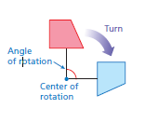
A ________________, or ____________, is a transformation in which a figure is rotated about a point called the ______________________. The number of degrees a figure rotates is the ________________________.

In a rotation, the original figure and its image are ______________.

Example 1: Identifying a Rotation
You must rotate the puzzle piece 270°clockwise about point P to fit it into a puzzle. Which piece fits in the puzzle as shown?

Rotate the puzzle piece 270°clockwise about point P.

On Your Own:
- Which piece is a 90° counterclockwise rotation about point P ?

- Is Choice D a rotation of the original puzzle piece? If not, what kind of transformation does the image show?

Example 2: Rotating a Figure
The vertices of a trapezoid are W(−4, 2), X(−3, 4), Y(−1, 4), and Z(−1, 2). Rotate the trapezoid 180° about the origin. What are the coordinates of the image?

Example 3: Rotating a Figure
The vertices of a triangle are J(1, 2), K(4, 2), and L(1, −3). Rotate the triangle 90° counterclockwise about vertex L. What are the coordinates of the image?

On Your Own:
3. A triangle has vertices Q(4, 5), R(4, 0), and S(1, 0).
a) Rotate the triangle 90° counterclockwise about the origin.
b) Rotate the triangle 180° about vertex S.
c) Are the images in parts (a) and (b) congruent? Explain.

Example 4: Using More than One Transformation
The vertices of a rectangle are A(−3, −3), B(1, −3), C(1, −5), and D(−3, −5). Rotate the rectangle 90° clockwise about the origin, and then reflect it in the y-axis. What are the coordinates of the image?

Example 5: Describing a Sequence of Transformations
The red figure is congruent to the blue figure. Describe a sequence of transformations in which the blue figure is the image of the red figure.

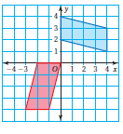

2.5 Similar Figures
Standards  8.G.4 | Learning Objectives (I can…)  - Name corresponding angles and corresponding sides of similar figures.  - Identify similar figures  - Find unknown measures of similar figures.

Key Idea
Figures that have the same shape but ______ necessarily the same size are called _____________ _____________.

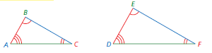

Two figures are similar when
- Corresponding sides lengths are proportional
- Corresponding angles are congruent.

Symbols Side Lengths Angles Figures

Example 1: Identifying Similar Figures

Which rectangle is similar to Rectangle A?

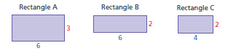

On Your Own:
- Rectangle D is 3 units long and 1 unit wide. Which rectangle is similar to Rectangle D?

Example 2: Finding an Unknown Measure in Similar Figures

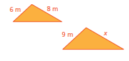
The triangles are similar. Find x.

Because the triangles are similar, corresponding side lengths are
proportional. So, write and solve a proportion to find x.

On Your Own:
The figures are similar. Find x.

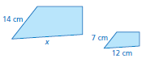
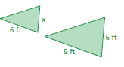
- 3.

Example 3: Real-Life Application

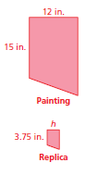
An artist draws a replica of a painting that is on the Berlin Wall. The painting includes a red trapezoid. The shorter base of the similar trapezoid in the replica is 3.75 inches. What is the height h of the trapezoid in the replica?
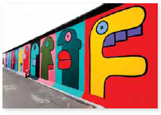

On Your Own:
- WHAT IF? The longer base in the replica is 4.5 inches. What is the length of the longer base in the painting?

2.6 Perimeters and Areas of Similar Figures
Standards  8.G.4 | Learning Objectives (I can…)  - Understand the relationship between perimeters and similar figures.  - Understand the relationship between areas and similar figures.

Key Idea
Perimeters of Similar Figures

When two figures are similar, the ratio of their perimeters is equal to the ratio of their corresponding side lengths.
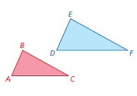

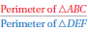

Example 1: Finding Ratios of Perimeters

Find the ratio (red to blue) of the perimeters of the similar rectangles.

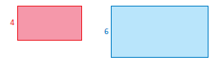

On Your Own:
- The height of Figure A is 9 feet. The height of a similar Figure B is 15 feet. What is the ratio of the perimeter of A to the perimeter of B ?

Key Idea
Areas of Similar Figures
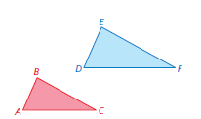
When two figures are similar, the ratio of their _____________ is equal to the square of the ratio of their _______________________ side lengths.

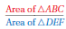

Example 2: Finding Ratios of Areas

Find the ratio (red to blue) of the areas of the similar triangles.

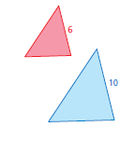

On Your Own:
- The base of Triangle P is 8 meters. The base of a similar Triangle Q is 7 meters. What is the ratio of the area of P to the area of Q?

Example 3: Using Proportions to Find Perimeters and Areas

A swimming pool is similar in shape to a volleyball court. Find the perimeter P and the area A of the pool.

The rectangular pool and the court are similar. So, use the ratio of corresponding side lengths to write and solve proportions to find the perimeter and the area of the pool.

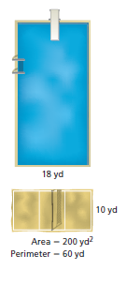

Perimeter Area

On Your Own:
- WHAT IF? The width of the pool is 16 yards. Find the perimeter P and the area A of the pool.

2.7 Dilations
Standards  8.G.3  8.G.4 | Learning Objectives (I can…)  - Identify dilations.  - Dilate figures in the coordinate plane.  - Use more than one transformation to find images of figures.

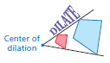
A _____________________ is a transformation in which a figure is made larger or smaller with respect to a point called the ________________________________.

Example 1: Identifying a Dilation

Tell whether the blue figure is a dilation of the red figure.

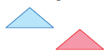
- b.

On Your Own:
Tell whether the blue figure is a dilation of the red figure. Explain.

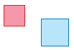
- 2.

In a dilation, the original figure and its image are ________________. The ratio of the side lengths of the image to the corresponding side lengths of the original figure is the _____________________ of the dilation.

Key Idea
Dilations in the Coordinate Plane

To dilate a figure with respect to the origin, multiply the coordinates of each vertex by the scale factor k.

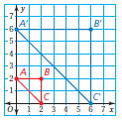
Algebra:

When k > 1, the dilation is an ____________________.

When k > 0 and k < 1, the dilation is a ________________.

Example 2: Dilating a Figure

Draw the image of Triangle ABC after a dilation with a scale factor of 3. Identify the type of dilation.

Vertices of ABC | ( , ) | Vertices of A’B’C’

Example 3: Dilating a Figure

Draw the image of Rectangle WXYZ after a dilation with a scale factor of 0.5. Identify the type of dilation.

Vertices of WXYZ | ( , ) | Vertices of W’X’Y’Z’

On Your Own:
- WHAT IF? Triangle ABC in Example 2 is dilated by a scale factor of 2. What are the coordinates of the image?

