1.1 Solving Simple Equations
Standards  8.EE.7a  8.EE.7b | Learning Objectives (I can…)  - Solve simple equations using addition, subtraction, multiplication, or division.

Key Idea
Addition Property of Equality
Words: _______________________ the same number to each side of an equation produces an ____________________________ equation.
Algebra:

Subtraction Property of Equality
Words: ________________________ the same number from each side of an equation produces an _____________________________ equation.
Algebra:

Example 1: Solving Equations Using Addition or Subtraction
- Solve $x-7=-6$

- Solve $y+3.4=0.5$

- Solve $h+2π=3π$

On Your Own: Solve the equation and check the solution.
- $b+2=-5$ 2. $g-1.7=-0.9$

- $-3=k+3$ 4. $r-π=π$

- $t-\frac{1}{4}=-\frac{3}{4}$ 6. $5.6+z=-8$

Key Idea
Multiplication Property of Equality
Words: _______________________ each side of an equation by the same number produces an ____________________________ equation.
Algebra:

Division Property of Equality
Words: ________________________ each side of an equation by the same number produces an _____________________________ equation.
Algebra:

Example 2: Solving Equations Using Multiplication or Division
- Solve $-\frac{3}{4}n=-2$

- Solve $πx=3π$

On Your Own: Solve the equation and check the solution.
- $\frac{y}{4}=-7$ 8. $6π=πx$

- $0.09w=1.8$

Example 3: Solving an Equation
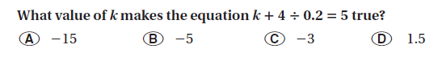

Example 4: Real-Life Application
The melting point of a solid is the temperature at which the solid becomes a liquid. The melting point of bromine is $\frac{1}{30}$ of the melting point of nitrogen. Write and solve an equation to find the melting point of nitrogen.
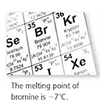
Words:

Variable:

Equation:

On Your Own:
- Solve $p-8÷\frac{1}{2}=-3$ 11. Solve $q+\left|-10\right|=2$

12. The melting point of mercury is about $\frac{1}{4}$ of the melting point of krypton. The melting point of mercury is −39 $℃$. Write and solve an equation to find the melting point of krypton.

1.2 Solving Multi-Step Equations
Standards  8.EE.7a  8.EE.7b | Learning Objectives (I can…)  - Use inverse operations to solve multi-step equations  - Use the Distributive Property to solve multi-step equations

Key Idea
Solving Multi-Step Equations
To solve multi-step equations, use ___________________ operations to isolate the variable.

Example 1: Solving a Two-Step Equation
The height (in feet) of a tree after x years is 1.5x + 15. After how many years is the tree 24 feet tall?

Example 2: Combing Like Terms to Solve an Equation
Solve 8x − 6x − 25 = −35.

On Your Own:
- $-3z+1=7$ 2. $\frac{1}{2}x-9=-25$

- $-4n-8n+17=23$

Example 3: Using the Distributive Property to Solve an Equation
Solve 2(1 − 5x) + 4 = −8.

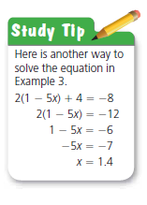

Example 4: Real-Life Application
Use the table to find the number of miles x you need to run on Friday so that the mean number of miles run per day is 1.5.

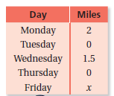
Write an equation using the definition of mean.

On Your Own:
- −3(x + 2) + 5x = −9 5. 5 + 1.5(2d − 1) = 0.5

- You scored 88, 92, and 87 on three tests. Write and solve an equation to find the score you need on the fourth test so that your mean test score is 90.

1.3 Solving Equations with Variables on Both Sides
Standards  8.EE.7a  8.EE.7b | Learning Objectives (I can…)  - Solve equations with variables on both sides.  - Determine whether equations have no solution or infinitely many solutions

Key Idea
Solving Equations with Variables on Both Sides
To solve equations with variables on both sides, collect the _______________ terms on one side and the _______________________ terms on the other side.

Example 1: Solving an Equation with Variables on Both Sides
Solve 15 − 2x = −7x. Check your solution.

Example 2: Solving Equations with Variables on Both Sides
a. Solve 3(5x + 2) = 15x. b. Solve −2(4y + 1) = −8y − 2.

On Your Own: Solve the equation. Check your solution, if possible.
1. −3x = 2x + 19 2. 4(1 − p) = − 4p + 4

3. 6m − m = $\frac{5}{6}$(6m − 10) 4. 10k + 7 = − 3 − 10k

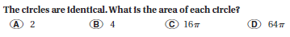
Example 3: Writing and Solving an Equation

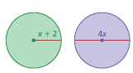

Example 4: Real-Life Application
A boat travels x miles per hour upstream on the Mississippi River. On the return trip, the boat travels 2 miles per hour faster. How far does the boat travel upstream?

The speed of the boat on the return trip is (x + 2) miles per hour.
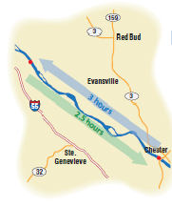

On Your Own:
- WHAT IF? In Example 3, the diameter of the purple circle is 3x. What is the area of each circle?

- A boat travels x miles per hour from one island to another island in 2.5 hours. The boat travels 5 miles per hour faster on the return trip of 2 hours. What is the distance between the islands?

1.4 Rewriting Equations and Formulas
Standards  8.EE.7 | Learning Objectives (I can…)  - Rewrite equations to solve one variable in terms of the other variable(s).

An equation that has two or more variables is called a __________________________. To rewrite a literal equation, solve for ____________ variable in terms of the other variable(s).

Example 1: Rewriting an Equation
Solve the equation 2y + 5x = 6 for y.

On Your Own:
Solve the equation for y.

1. 5y − x = 10 2. 4x − 4y = 1

3. 12 = 6x + 3y

Create Your Own Example:

Example 2: Rewriting a Formula
The formula for the surface area S of a cone is $πr^{2}+πrl$. Solve the formula for the slant height $l$.

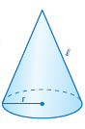

On Your Own:
Solve the formula for the bold variable.
4. Area of rectangle: A = bh 5. Simple interest: I = Prt

6. Surface area of cylinder: $S=2πr^{2}+2πrh$

Key Idea
Temperature Conversion
A formula for converting from degrees Fahrenheit F to degrees Celsius C is

Example 3: Rewriting the Temperature Formula
Solve the temperature formula for F.

Example 4: Real-Life Application
Which has the greater temperature?

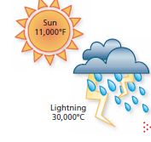

On Your Own:
- Room temperature is considered to be 70$℉$. Suppose the temperature is 23$℃$. Is this greater than or less than room temperature?

