10.1 Exponents
Standards  8.EE.1 | Learning Objectives (I can…)  - Write expressions using integer exponents  - Evaluate expressions involving integer exponents

A ____________________ is a product of repeated factors. The _____________of a power is the common factor. The _________________ of a power indicates the number of times the base is used as a factor.
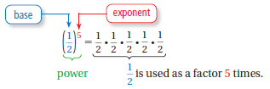

Example 1: Writing Expressions Using Exponents

Write each product using exponents

- $\left(-7\right)∙\left(-7\right)∙(-7)$

- $π∙π∙r∙r∙r$

On Your Own:
- $\frac{1}{4}∙\frac{1}{4}∙\frac{1}{4}∙\frac{1}{4}∙\frac{1}{4}$ 2. $0.3∙0.3∙0.3∙0.3∙x∙x$

Example 2: Evaluating Expressions

Evaluate each expression.

- ${(-2)}^{4}$

- ${-2}^{4}$

Example 3: Using Order of Operations

Evaluate each expression.

- $3+2∙3^{4}$

- $3^{3}-8^{2}÷2$

On Your Own:

- ${-5}^{4}$ 4. ${(-\frac{1}{6})}^{3}$ 5. $\left|{-3}^{3}÷27\right|$ 6. $9-2^{5}∙0.5$

Example 4: Real Life Application

In sphering, a person is secured inside a small, hollow sphere that is surrounded by a larger sphere. The space between the spheres is inflated with air. What is the volume of the inflated space?

You can find the radius of each sphere by dividing each diameter given in the diagram by 2.

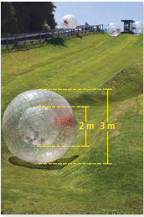

On Your Own:
7. WHAT IF? The diameter of the inner sphere is 1.8 meters. What is the volume of the inflated space?

10.2 Product of Powers Property
Standards  8.EE.1 | Learning Objectives (I can…)  - Multiply powers with the same base  - Find a power of a power  - Find a power of a product

Key Idea
Product of Powers Property

Words: To multiply powers with the same base, _________________ their exponents.

Numbers: Algebra:

Power of Power Property

Words: To find a power of a power, _________________ the exponents.

Numbers: Algebra:

Power of a Product Property

Words: To find a power of a product, find the power of each factor and ____________________.

Numbers: Algebra:

Example 1: Multiplying Powers with the Same Base

- $2^{4}∙2^{5}$

- $-5∙{(-5)}^{6}$

- $x^{3}∙x^{7}$

Example 2: Finding a Power of a Power

- ${(3^{4})}^{3}$

- ${(w^{5})}^{4}$

Example 3: Finding a Power of a Product

- ${(2x)}^{3}$

- ${(3xy)}^{2}$

Example 4: Simplifying an Expression

A gigabyte (GB) of computer storage space is $2^{30}$ bytes. The details of a computer are shown. How many bytes of total storage space does the computer have?
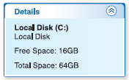

The computer has 64 gigabytes of total storage space. Notice that you can write 64 as a power, $2^{6}$. Use a model to solve the problem.

10.3 Quotient of Powers Property
Standards  8.EE.1 | Learning Objectives (I can…)  - Divide powers with the same base  - Simplify expressions involving the quotient of powers

Key Idea
Quotient of Powers Property

Words: To divide powers with the same base, _________________ their exponents.

Numbers: Algebra:

Example 1: Dividing Powers with the Same Base

- $\frac{2^{6}}{2^{4}}$

- $\frac{{(-7)}^{9}}{{(-7)}^{3}}$

- $\frac{h^{7}}{h^{6}}$

On Your Own:
- $\frac{9^{7}}{9^{4}}$ 3. $\frac{{(-8)}^{8}}{{(-8)}^{4}}$

- $\frac{{4.2}^{6}}{{4.2}^{5}}$ 4. $\frac{x^{8}}{x^{3}}$

Example 2: Simplifying an Expression

Simplify $\frac{3^{4}∙3^{2}}{3^{3}}$ . Write your answer as a power.
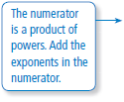
$\frac{3^{4}∙3^{2}}{3^{3}}$

Example 3: Simplifying an Expression

Simplify $\frac{a^{10}}{a^{6}}∙\frac{a^{7}}{a^{4}}$ . Write your answer as a power.

On Your Own:
- $\frac{2^{15}}{2^{3}∙2^{5}}$ 6. $\frac{d^{5}}{d}∙\frac{d^{9}}{d^{8}}$ 7. $\frac{5^{9}}{5^{4}}∙\frac{5^{5}}{5^{2}}$

Example 4: Real-Life Application

The projected population of Tennessee in 2030 is about $5∙{5.9}^{8}$. Predict the average number of people per square mile in 2030.

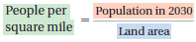
Use a model to solve the problem.

On Your Own:
The projected population of Alabama in 2030 is about $2.25∙2^{21}$. The land area of Alabama is about $2^{17}$ square kilometers. Predict the average number of people per square kilometer in 2030.

10.4 Zero and Negative Exponents
Standards  8.EE.1 | Learning Objectives (I can…)  - Evaluate expressions involving numbers with zero as an exponent  - Evaluate expressions involving negative integer exponents

Key Idea
Zero Exponents

Words: For any nonzero number a,_____________. The power $0^{0}$ is undefined.

Numbers: Algebra:

Negative Exponents

Words: For any integer n and any nonzero number a, _________________ is the reciprocal of $a^{n}$.

Numbers: Algebra:

Example 1: Evaluating Expressions

- $3^{-4}$

- ${(-8.5)}^{-4}∙{(-8.5)}^{4}$

- $\frac{2^{6}}{2^{8}}$

On Your Own:
Evaluate the expression.

- $4^{-2}$ 2. ${(-2)}^{-5}$ 3. $6^{-8}∙6^{8}$

- $\frac{{(-3)}^{5}}{{(-3)}^{6}}$ 5. $\frac{1}{5^{7}}∙\frac{1}{5^{-4}}$ 6. $\frac{4^{5}∙{ 4}^{-3}}{4^{2}}$

Example 2: Simplifying Expressions

- ${-5x}^{0}$

- $\frac{{9y}^{-3}}{y^{5}}$

On Your Own:
- ${8x}^{-2}$ 8. $b^{0}∙b^{-10}$ 9. $\frac{z^{6}}{{15z}^{9}}$

Example 3: Real-Life Application

A drop of water leaks from a faucet every second. How many liters of water leak from the faucet in 1 hour?

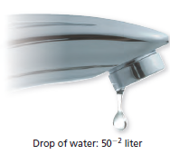
Convert 1 hour to seconds.

On Your Own:
10. WHAT IF? The faucet leaks water at a rate of 5−5 liter per second. How many liters of water leak from the faucet in 1 hour?

10.5 Reading Scientific Notation
Standards  8.EE.3  8.EE.4 | Learning Objectives (I can…)  - Identify numbers written in scientific notation  - Write numbers in scientific notation  - Compare numbers in scientific notation

Key Idea
Scientific Notation

A number is written in _____________________________ when it is represented as the product of a factor and a power of 10. The factor must be greater than or equal to _______ and less than _______.

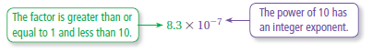

Example 1: Identifying Numbers Written in Scientific Notation

Tell whether the number is written in scientific notation. Explain.

- ${5.9 ×10}^{-6}$

- $0.9×{10}^{8}$

Key Idea
Writing Numbers in Standard Form

The absolute value of the exponent indicates how many places to move the decimal point.

- If the exponent is ________________, move the decimal point to the ___________.

- If the exponent is ________________, move the decimal point to the ___________.
Example 2: Writing Numbers in Standard Form

- Write ${3.22 ×10}^{-4}$ in standard form.

- Write $7.9×{10}^{5}$ in standard form.

On Your Own:
- Is $12×{10}^{4}$ written in scientific notation? Explain.

Write the number in standard form.

- $6×{10}^{7}$ 3. $9.9×{10}^{-5}$ 4. $1.285×{10}^{4}$

Example 3: Comparing Numbers in Scientific Notation

An object with a lesser density than water will float. An object with a greater density than water will sink. Use each given density (in kilograms per cubic meter) to explain what happens when you place a brick and an apple in water.

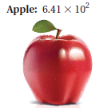
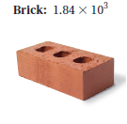
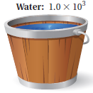

Example 4: Real-Life Application

A dog has 100 female fleas. How much blood do the fleas consume per day?

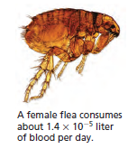

On Your Own:
- WHAT IF? In Example 3, the density of lead is 1.14 × 104 kilograms per cubic meter. What happens when you place lead in water?

- WHAT IF? In Example 4, a dog has 75 female fleas. How much blood do the fleas consume per day?

10.6 Writing Scientific Notation
Standards  8.EE.3  8.EE.4 | Learning Objectives (I can…)  - Write large and small numbers in scientific notation  - Perform operations with numbers written in scientific notation

Key Idea
Writing Numbers in Scientific Notation

Step 1: Move the decimal point so it is located to the ________________ of the leading nonzero digit.

Step 2: Count the number of __________________you moved the decimal point. This indicates the exponent of the power of ______________, as shown below.

Number Greater Than or Equal to 10 Number Between 0 and 1
Use a _____________ exponent when Use a _______________ exponent when
you move the decimal point you move the decimal point to
to the left. the right.

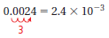
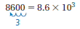

Example 1: Writing Large Numbers in Scientific Notation

Google purchased YouTube for $1,650,000,000. Write this number in scientific notation.

Example 2: Writing Small Numbers in Scientific Notation

The 2004 Indonesian earthquake slowed the rotation of Earth, making the length of a day 0.00000268 second shorter. Write this number in scientific notation.

On Your Own:
Write the number in scientific notation.

- 500,000 2. 25,000,000 3. 683

- 0.005 5. 0.00000033 6. 0.000506

Example 3: Using Scientific Notation

An album has sold 8,780,000 copies. How many more copies does it need to sell to receive the award?

Example 3: Real-Life Application

The table shows when the last three geologic eras began. Order the eras from earliest to most recent.
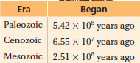

10.7 Operations in Scientific Notation
Standards  8.EE.3  8.EE.4 | Learning Objectives (I can…)  - Add, subtract, multiply, and divide numbers written in scientific notation.

To add or subtract numbers written in scientific notation with the same power of 10, add or subtract the __________________. When the numbers have different powers of 10, first ________________ the numbers so they have the same power of 10.

Example 1: Adding and Subtracting Numbers in Scientific Notation

Find the sum or difference. Write your answer in scientific notation.

- ${(4.6 ×10}^{3})+(8.72×{10}^{3})$

- $\left(3.5×{10}^{-2}\right)-(6.6×{10}^{-3})$

On Your Own:
Find the sum or difference. Write your answer in scientific notation.

- $\left(3×{10}^{2}\right)+(3.41×{10}^{-1})$ 2. $\left(7.9×{10}^{-5}\right)-(4.5×{10}^{-5})$

To multiply or divide numbers written in scientific notation, multiply or divide the factors and powers of 10 ________________________.

Example 2: Multiplying Numbers in Scientific Notation

Find $(3×{10}^{-5})×(5×{10}^{-2})$. Write your answer in scientific notation.

Example 3: Dividing Numbers in Scientific Notation

Find $\frac{1.5×{10}^{-8}}{6×{10}^{7}}$. Write your answer in scientific notation.

On Your Own:
Find the product or quotient. Write your answer in scientific notation.

- $6×(8×{10}^{-5})$ 4. $(7×{10}^{2})×(3×{10}^{5})$

- $\left(9.2×{10}^{12}\right)÷4.6$ 6. $(1.5×{10}^{-3})÷(7.5×{10}^{2})$

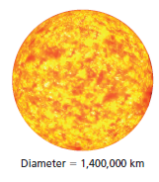
Example 4: Real-Life Application

How many times greater is the diameter of the Sun than the diameter of Earth?

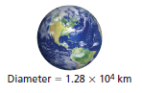
Write the diameter of the Sun in scientific notation.

